Hannah Munoz

1. 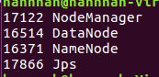
2. 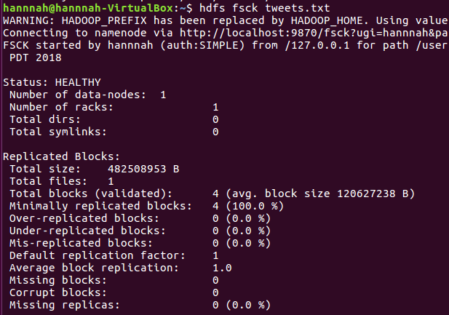

4 blocks

3.

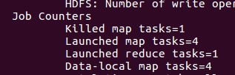

4 block means 4 map task

4.

